The Impact of Covid-19 on Aviation: The Economic, Social, Operational, and Litigation Fallout

Introduction

The COVID-19 pandemic (hereinafter “COVID”) has had a profound influence on American life. The focus of this paper is the economic, structural, social, and litigation impact of COVID on the aviation industry. However, a brief contextual discussion may provide helpful context.

According to the United Nations, COVID-related case counts and deaths globally as of 5/7/22 are as follows:

Confirmed Cases Deaths

516,904,681 6,250,163
Epidemics, and, as the world became larger, pandemics, have ravaged the globe for thousands of years. In 430 BC, a plague struck the city of Athens, which was then under siege by Sparta during the Peloponnesian War (431-404 BC). In the next 3 years, nearly the entire population was infected and as many as 100,000 people, or 25% of what was then the largest city on earth, died. During the plague of Justinian, which began in about 542 A.D., the Black Death pandemic killed up to 10,000 people a day, just in the City of Constantinople. Modern estimates suggest that one hundred million deaths (half of Europe) died by the time the pandemic subsided.

COVID Continues to have, a Profound Impact on Global Aviation

Passenger traffic in April 2020 was 96% lower than April 2019 and stayed 60% below 2019 levels in 2020. Effects cascaded across airports, repair shops, and the supply chain. In response to reduced demand, particularly at the outset of COVID in 2019 airlines parked or retired many aircraft, which reduced the demand for maintenance.

COVID had, and continues to have, a profound impact on the U.S. aviation industry. Stakeholders noted the importance of over $100 billion in federal assistance for the aviation sector, including payrolls, rents and more FAA actions included temporary relief from some regulatory requirements.
Stakeholders also noted the importance of the over $100 billion in payroll support payments, loans, and other financial assistance provided through COVID-19 relief legislation.
Although airlines experienced a rebound in demand for U.S. leisure travel in 2021, operational challenges and concerns about the COVID-19 Delta variant have slowed recovery. Forecasts suggest that industry recovery will be uneven as business and international air travel—the most profitable segments—are likely to lag.

U.S. Airline Passenger Traffic, Percentage Change 2019 versus 2020

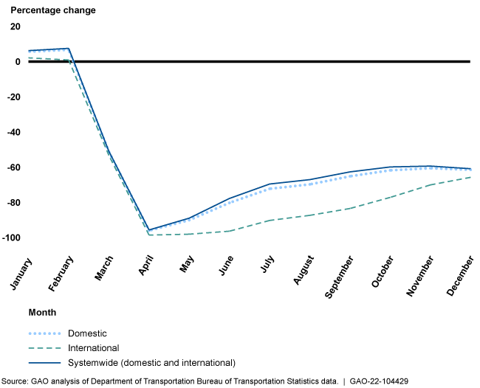

Latin America-Caribbean | 10,500 | 5,200 | -50.5%
Middle East | 13,200 | 6,200 | -53.0%
North America | 34,700 | 18,300 | -43.3%
World | 171,900 | 74,500 | -56.7%
Source: Airports Council International (ACI)

COVID’s Impact on Airlines

All regions contributed to the overall losses in 2020, including North America. Five of the world’s ten top-performing airlines during the during the 2012-2019 period were based in the United States, where years of consolidation and restructuring had left the North American market with a few leading players. However, the major airlines were not immune from the COVID pandemic and lost $63 billion in 2020 alone. While full data is not yet available for 2021, the McKinsey study estimates net losses of around 11 percent.

Reasons for the persistent weakness of airlines are well documented and include high capital intensity, fluid supply and low entry barriers. The large field of carriers means that suppliers such as OEMs and airports have stronger negotiating power. On the customer side, passengers hold significant power and are price driven. The airline seat remains commoditized despite airline efforts at differentiation.

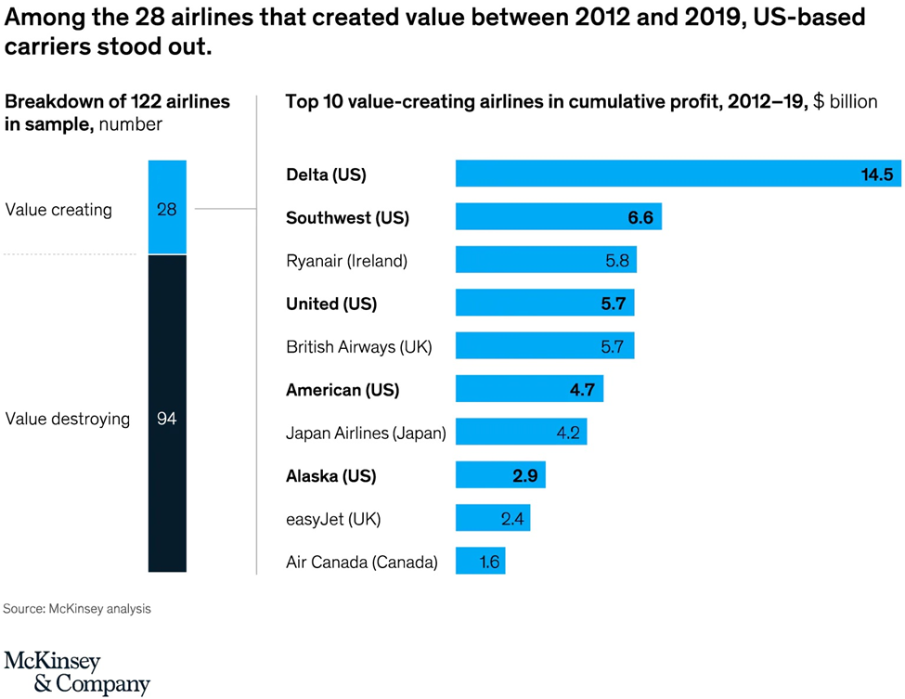

COVID’S Impact on Aviation Manufacturing

General Aviation Manufacturers Association (GAMA) leaders have forecasted a healthy rebound in aircraft demand once the impact of the COVID pandemic has passed. This is in part due to expected innovations in electric propulsion and supersonic technologies. Speaking at the GAMA 2021 State of the Industry address, GAMA Chair Nicolas Chabbert noted that the pandemic caused a 9.7% decline in airplane shipments in 2020 and a 14.8% drop in total airplane billings.

NBAA and GAMA data suggest that while GA manufacturing experienced a Q4 2020 rebound, the pandemic still had heavy negative impact on 2020 shipments and billings. The least affected segment, piston airplanes, saw deliveries drop just 0.9% year-over-year to 1,312 units, but turboprop shipments declined 15.6% to 443 units and business jet deliveries fell 20.4% to 644 aircraft. The value of airplane deliveries for 2020 dropped 14.8 percent compared to 2019 to $20 billion. Preliminary civil-commercial helicopter deliveries also fell 17.7% to 674 units and billings dropped 16.2% to 2.7 billion compared to 2019.

Airbus and Boeing are expected to deliver a total of 539 and 910 new planes in 2020 and 2021, respectively, compared with 1,610 in 2018 and 1,243 in 2019. The lower number in 2019 is the consequence of the flying ban imposed on Boeing 737 Max jets since March 2019, and while 2021 and beyond should see a slight recovery, the number of new plane deliveries is still likely to remain far below its pre-pandemic level of 1,600 units a year if the global economy remains off track.

COVID’S Impact on the Aviation Insurance Market and the Key Role of Insurers and Brokers

By the end of March 2020, approximately 8,500 airliners were grounded. One of the initial insurance risks was mass accumulation. The mass accumulation exposes aviation insurers to significant one-off loss events such as tornadoes, hail, terrorist attacks and other catastrophes that could create billions of dollars in losses at once. The aviation insurance market has suffered significant losses in recent years, most notably related to the grounding of the Boeing 737 Max. Through 2019 and 2020, the global aviation insurance marketplace hardened, but COVID will slow down insurer efforts to return balance sheets to a healthy place.

When large fleets of aircraft are grounded, the insured airlines typically request one of two things. They request either ground breaks, which typically means a request to pay a lower premium, or they ask for a lay-up credit, which impacts the aviation insurance marketplace by lowering the amount of available premium. If the insurers agree to premium credits on hull and liability policies, the credits are typically between 30-50% of the annual premium on a prorated basis. The average cost of a claim has spiked between 32% and 133% depending on the loss.

Flight Crew Mask Mandate Litigation

Judge Kimberly Mizelle’s Decision Striking Down the Biden Administration’s Mask Mandate

On April 18, 2022, U.S. District Judge for the Judge Kimberly Mizelle, (U.S. District Court for the Middle district of Florida) struck down the mask mandate. In Health Freedom Defense Fund, Inc., et al., v Joseph R. Biden, Jr. Case No 8:21-cv-01693-KKM-AEP, 2022 WL 1134138 4/18/22 the court issued its 59-page opinion. The judge’s decision freed airlines, airports, and mass transit systems to make their own decisions about mask requirements. The major airlines immediately switched to a mask optional policy.

Judge Mizelle, an appointee of former President Donald Trump, said the U.S. Centers for Disease Control and Prevention exceeded the bounds of their authority, failed to justify their decision, and did not follow proper rulemaking procedures leaving the ask mandate fatally flawed.

The U.S. Department of justice has been silent about plans to challenge the ruling. Although Judge Mizelle’s opinion is likely to face challenges, it follows countless lawsuits challenging the mask mandates.

Passenger Refund Lawsuits

In 2020, airlines faced over thirty class actions seeking refunds for COVID-19 related flight cancellations. A representative sample is discussed below.

In this section, we address a sample of these cases through review of a case filed against United Airlines. In Rudolph v United Airlines Holdings, Inc., Case No. 1:20-cv-02142, United States District Court for the Northern District of Illinois, 519 F. Supp.3d 438, 2/12/21, 2020 WL 1676340. Plaintiff Jacob Rudolph booked flights for April 2020 on United. However, in March, plaintiffs’ employer-a police department-cancelled all vacation for officers as the pandemic began to surge.

Plaintiff requested a refund from United which was denied. United explained that a refund would only be issued if the flight was cancelled, and instead offered to book him on a different flight or issue a travel credit. Plaintiff’s flight was cancelled, but United continued to deny any refund. The complaint also cites a letter to United’s CEO from several Senators urging the company to issue refunds, especially given the $25 billion in federal aid recently issued to the airline industry. Plaintiff seeks class certification for a class defined as other in the U.S. who booked flights with United from March 1, 2020, through present day and were denied a refund.

On April 6, 2020, plaintiff filed the class action complaint. United filed motions for summary judgement and motions to stay, which were abated pending arbitration. On 7/17/2020, plaintiffs moved for transfer under 28 U.S.C. §1407 for coordinated pretrial proceedings with the COVID -19 Airfare Refund Litigation. A series of thirty-eight putative class actions pending in sixteen different U.S. District Courts alleging passenger airlines have refused to offer required refunds for flights the airlines cancelled in response to the COVID-19 pandemic. Discovery is proceedings and motions to compel have been filed.

United Nations Department of Economic and Social Affairs, Statistics UN COVID-19 Data Hub file:///C:/Users/sbrooksby/OneDrive%20-%20Olson%20Brooksby%20PC/Documents/UN%20COVID-19%20Data%20Hub.html Last visited 5/8/22
“ A sudden outbreak of infectious disease that spreads rapidly through the population, affecting a large proportion of people” Oxford English Dictionary, https://www.google.com/search?q=Oxford+english+dictionary+definition+of+epidemic&rlz=1C1CHBF_enUS922US922&oq=Oxford+english+dictionary+definition+of+epidemic&aqs=chrome..69i57j0i22i30j0i390.13462j0j15&sourceid=chrome&ie=UTF-8 Last visited 5/8/20.
“An epidemic occurring over a very wide area, crossing international boundaries, and usually affecting a large number of people”, Oxford Reference https://www.oxfordreference.com/view/10.1093/acref/9780199976720.001.0001/acref-9780199976720-e-1373#:~:text=An%20epidemic%20occurring%20over%20a,a%20large%20number%20of%20people. Last visited, 5/9/20.
“The plague of Athens: epidemiology and paleopathology,” Littman, Robert J., Mt. Sinai J Med. Oct. 2009 https://pubmed.ncbi.nlm.nih.gov/19787658/ Last visited, 5/10/22
“Plague was one of history’s deadliest diseases-then we found a cure” Howard, Jenny, National Geographic Society, July 6, 2020, https://m365.us.vadesecure.com/safeproxy/v4?f=WOgceN-hUA-lF2H7Gu4E6OavOR4gkpoT76yAub_HK0My0mPXQSLEB3c9BGmxW9RT&i=H_IkNxwocPmcSuFXDV8s8sgOdFCEcRjAMWiLtvNhShCUlXJ0_c59dRFswjfEjcJI497YQhVzTE0-e4-FyAhWfA&k=XX0E&r=nyuZQx9kXgS7mUxr1JCBMYxgNOLF_ovmS9tGeoZx0R0jAlnKrSMkd7u6Attj3S97&s=b63f4d3e15ec3b44f479e7c76cc27bb2360be2d8b225bfeec9ab5d343e7cd8e1&u=https%3A%2F%2Fwww.nationalgeographic.com%2Fscience%2Farticle%2Fthe-plague Last visited, 5/8/2020.
COVID-19 Pandemic: Observations on the Ongoing Recovery of the Aviation Industry, GAO-22-104429), October 21, 2021. https://www.gao.gov/products/gao-22-104429#:~:text=The%20COVID%2D19%20pandemic%20had,shops%2C%20and%20the%20supply%20chain. Last visited 5/6/2022.
Id.
Id.
Id.
“Aircraft Manufacturers optimistic for Robust Recovery from Pandemic Downturn, National Business Aviation Association, February 24, 2021 https://nbaa.org/aircraft-operations/safety/coronavirus/covid-19-point-of-impact/aircraft-manufacturers-optimistic-for-robust-recovery-from-pandemic-downturn/ Last visited 5/9/22
Id.
Id.
Id.
ACE, Aerospace Central Europe, “The Coronavirus Pandemic Poses a Unique Risk to the Aviation Industry and Compels Aviation Insurers and Brokers to Adapt Their Strategy”, April 2021, https://aero-space.eu/2021/01/04/the-coronavirus-pandemic-poses-a-unique-risk-to-the-aviation-industry-and-compels-aviation-insurers-and-brokers-to-adapt-their-strategy/ Last visited 5/10/22.
Id.
Id.

